- a) Positive
b) Flat
c) Negative

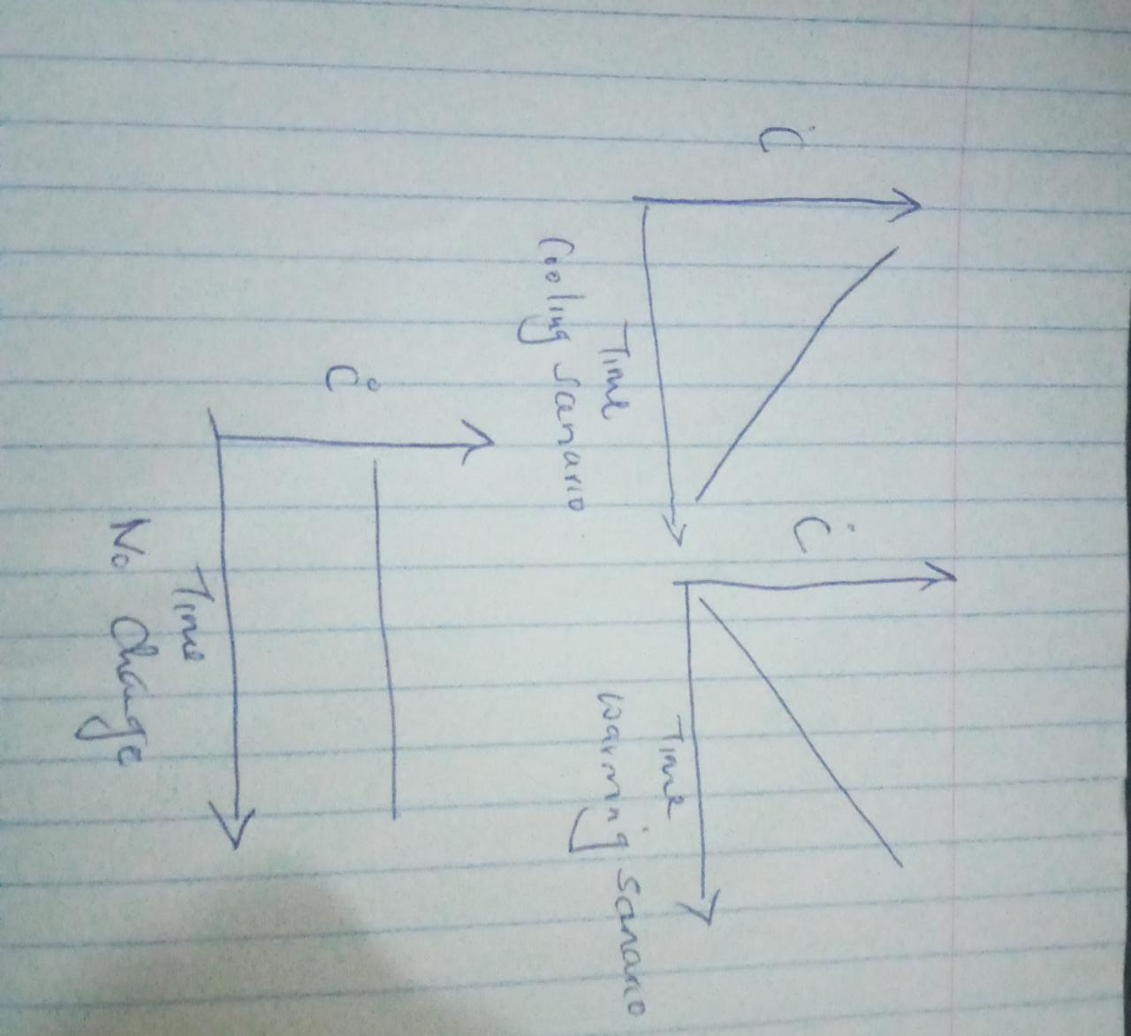

3
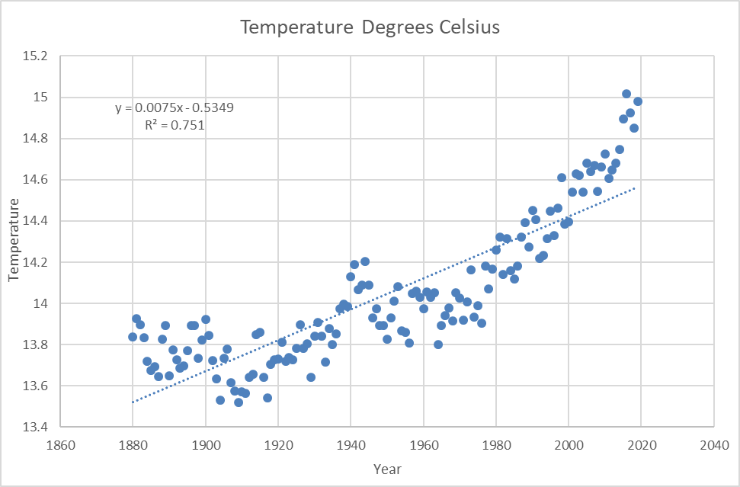
- y = 0.0075x - 0.5349
- R² = 0.751
- 0.0075
- The world is in a warming trend as the rate of change is positive as indicated in the equation

- y = 0.0149x - 15.191
- R² = 0.8716
- 0.0149
- The analysis supports the hypothesis that the rate of global average temperature is greater since the 1950 as 0.0149 is greater than 0.0075

6
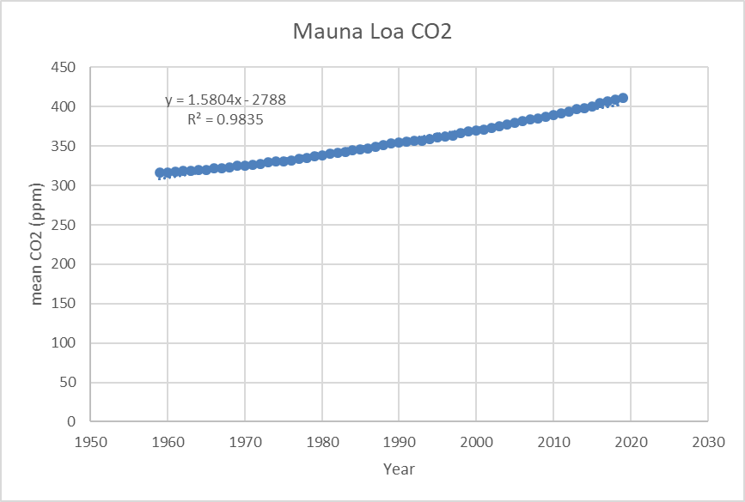

- y = 1.5804x – 2788
- R² = 0.9835
- 1.5804
- CO2 Concentration has increased over time as the rate of change is positive. This fact is affirmed by having a near one R². Consequently, the world is increasingly experiencing rising sea levels, heavy rains and heat waves.

7
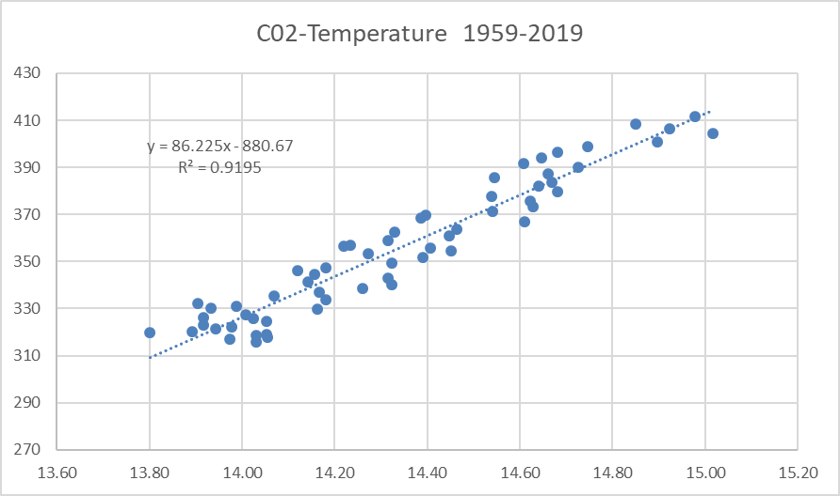

- y= 86.225x - 880.67
- R² = 0.9195
- 86.225
- According to the analysis above, atmospheric CO2 concentration explain the increase in average global temperature as the rate of change is positive.

8

- According to weather changes and the trend in global warming, I believe these data are a good representation of pre-historic rates of change
- interglacial
- Glacial last between 70,000 to 90,000 years while interglacial last approximately 10,000

9

The line is not a good representation of long-term rates of temperature change because R2 tend to be further from one

- Temperature change -0.0002
12

- The rate of change is statistically consistency with the website

13

Rate of change 0.006

